/***********************************************************************************************

File : DBMS

AuthorName : Abhishek Tiwari

Description : Query to display all the details from orders table for those orders placed by robert

Version : 1.0

Date : 11/12/2017

***********************************************************************************************/

**Solution 1.a**

SQL> SELECT * FROM orders

2 WHERE customer_id=(SELECT customer_id FROM customer

3 WHERE lower(customer_name)='robert');

**Output**

ORDER_ID ORDER_DAT PRODUCT_NAME PRODUCT_PRICE QUANTITY CUSTOMER_ID

---------- --------- -------------------- ------------- ---------- -----------

1001 22-FEB-16 Pen Drive 600 3 101

1003 12-MAR-16 Memory Card 450 3 101

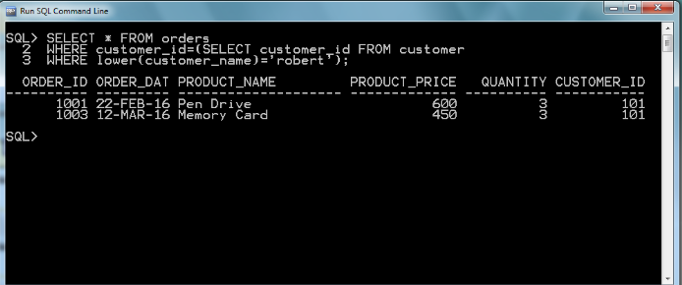

/***********************************************************************************************

File : DBMS

AuthorName : Abhishek Tiwari

Description : Query to display product name for which maximum orders have been placed.

Version : 1.0

Date : 11/12/2017

***********************************************************************************************/

**Solution 1.b**

SQL> SELECT product_name FROM orders

2 GROUP BY product_name

3 HAVING sum(quantity)=(SELECT max(sum(quantity)) FROM orders

4 GROUP BY product_name);

**output**

PRODUCT_NAME

--------------------

Memory Card

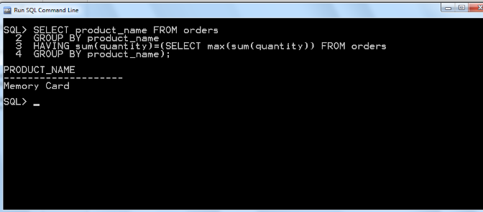

/***********************************************************************************************

File : DBMS

AuthorName : Abhishek Tiwari

Description : Query to ensure that product name entered should be one of the following names only: PenDrive MemoryCard or speaker

Version : 1.0

Date : 11/12/2017

***********************************************************************************************/

**Solution 1.c**

SQL> ALTER TABLE orders

2 ADD CONSTRAINT chk_product

3 CHECK(product_name='Pen Drive' OR

4 product_name='Memory Card' OR

5 product_name='Speaker');

**Output**

Table altered.

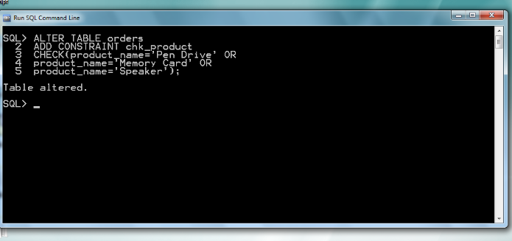

/*********************************************************************

**************************

File : DBMS

AuthorName : Abhishek Tiwari

Description : Insert commands

Version : 1.0

Date : 11/12/2017

**********************************************************************

*************************/

**Solution 2**

SQL> INSERT INTO orders VALUES(order_id_seq.nextval,'&order_dat','&product_name'

,&product_price,&quantity,&customer_id);

Enter value for order_dat: 22-Sep-2017

Enter value for product_name: Pen Drive

Enter value for product_price: 300

Enter value for quantity: 2

Enter value for customer_id: 101

old 1: INSERT INTO orders VALUES(order_id_seq.nextval,'&order_dat','&product_n

ame',&product_price,&quantity,&customer_id)

new 1: INSERT INTO orders VALUES(order_id_seq.nextval,'22-Sep-2017','Pen Drive

',300,2,101)

1 row created.

SQL> INSERT INTO orders VALUES(order_id_seq.nextval,'&order_dat','&product_name'

,&product_price,&quantity,&customer_id);

Enter value for order_dat: 12-Oct-2017

Enter value for product_name: Memory Card

Enter value for product_price: 400

Enter value for quantity: 5

Enter value for customer_id: 105

old 1: INSERT INTO orders VALUES(order_id_seq.nextval,'&order_dat','&product_n

ame',&product_price,&quantity,&customer_id)

new 1: INSERT INTO orders VALUES(order_id_seq.nextval,'12-Oct-2017','Memory Ca

rd',400,5,105)

1 row created.

